TERMINATING DEDUCTIONS AND BENEFITS

There has been some confusion about what expiration date to use when terminating a deduction and benefit and what is the last check date in which the deduction or benefit will be taken. Below is a process to use that will, hopefully, make this easier.

- Always expire a deduction or benefit on the last day of a pay period.

- If you want the last deduction to be taken from the paycheck dated at the end of the current pay period, the expiration date would be the last day of the previous pay period.

- If you want the last deduction to be taken from the paycheck dated at the end of the next pay period, the expiration date would be the last day of the current pay period.

Last Deduction Taken from Pay Check Dated at the End of the Current Pay Period

An employee resigns effective January 8, 2001. You want their last deductions to be taken from the pay check that will be dated January 15, 2001. [Remember, the check dated January 15, 2001 is for the pay period of December 16- 31, 2000.]

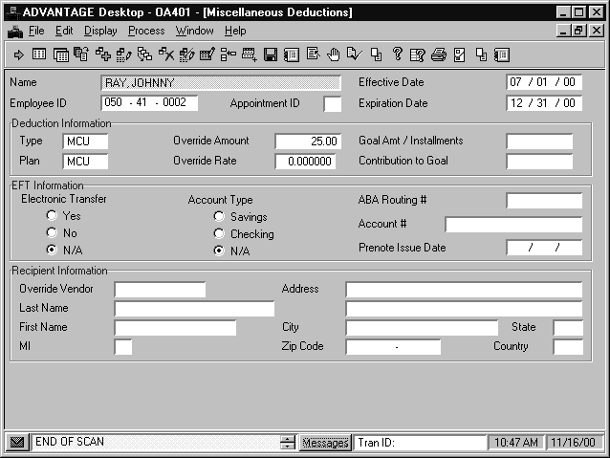
You would put the date of December 31, 2000 in the expiration date field on the MISC, SAVB, or ENRL window.

The last credit union deduction taken for this employee would be on their January 15th check.

Last Deduction Taken from Pay Check Dated at the End of the Next Pay Period

An employee resigns effective January 8, 2001. You want their last deductions to be taken from the paycheck that will be dated January 31, 2001. [Remember, the check dated January 31, 2001 is for the pay period of January 1 – 15, 2001.]

You would put the date of January 15, 2001 in the expiration date field on the MISC, SAVB, or ENRL window.
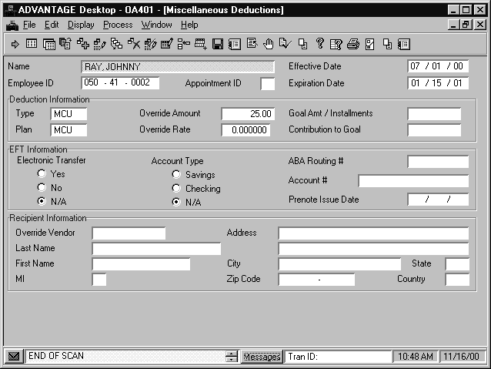

The last credit union deduction taken for this employee would be on their January 31st check.

MCHCP and MOSERS

If you have any questions about when the last deduction should be taken for MCHCP and MOSERS, you should contact MCHCP or MOSERS.

