Script to Print Report Pages

- Open the Mobius report you wish to record a script for.
- Set your print options to print reports as you normally would.
- From the menu bar select Script/Start Recording or select the Script Start Recording icon

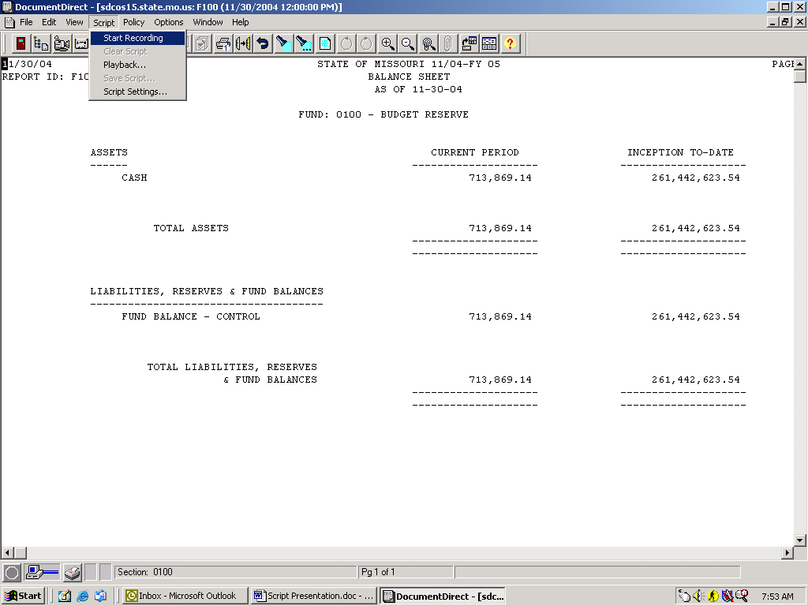

- Begin searching and printing report pages as you normally would. The recorder is documenting your movements. If you undo one of your commands it will not effect the recording. In our example we are printing fund pages 0100 and 0104.

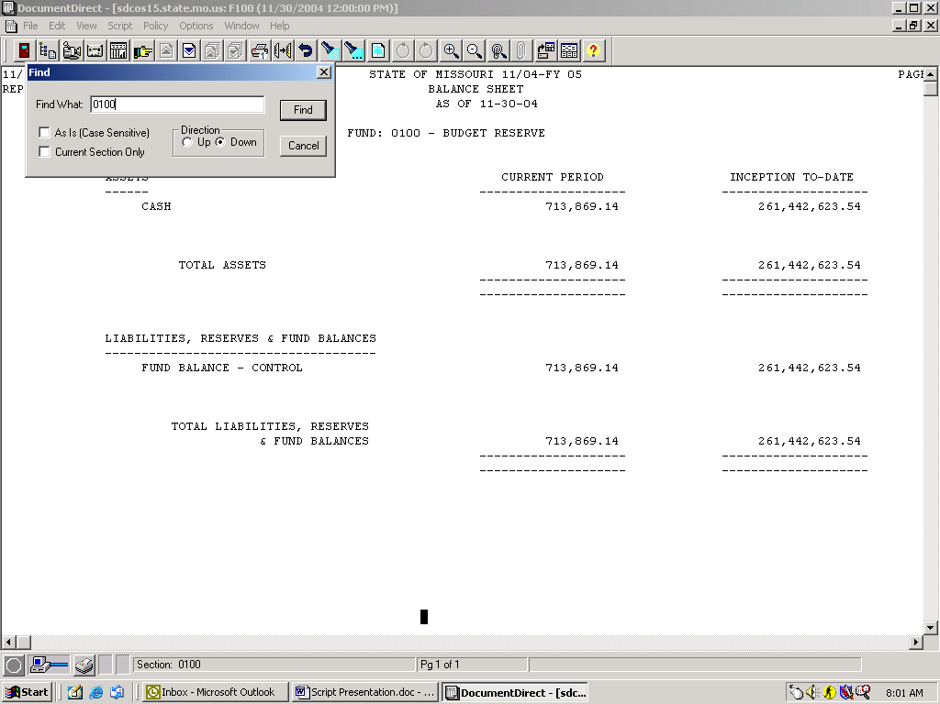

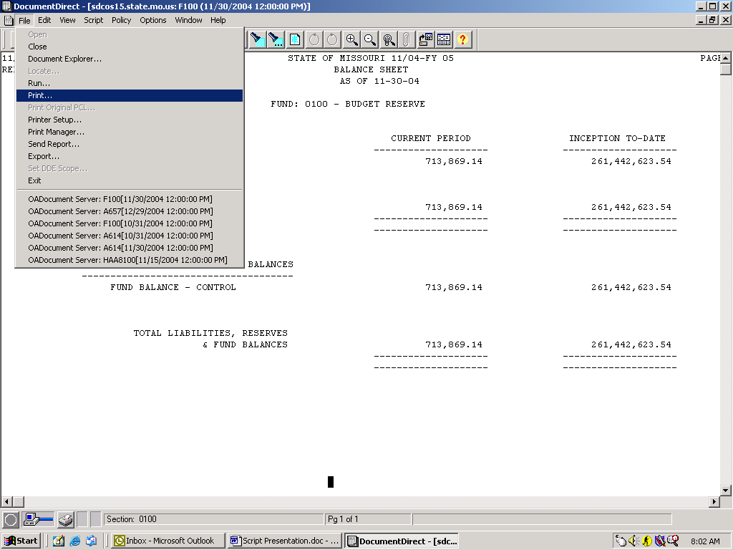

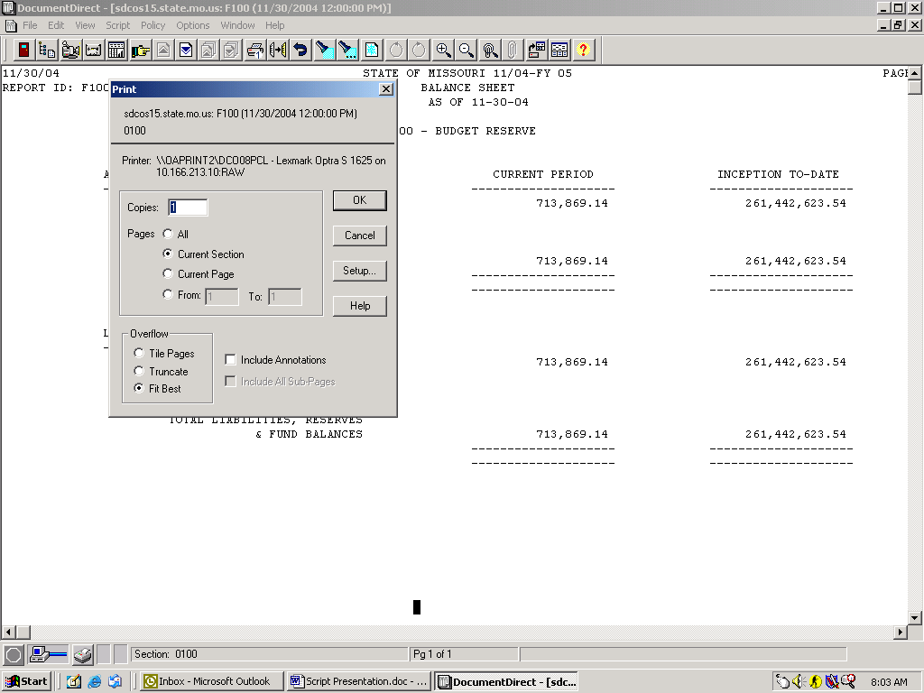

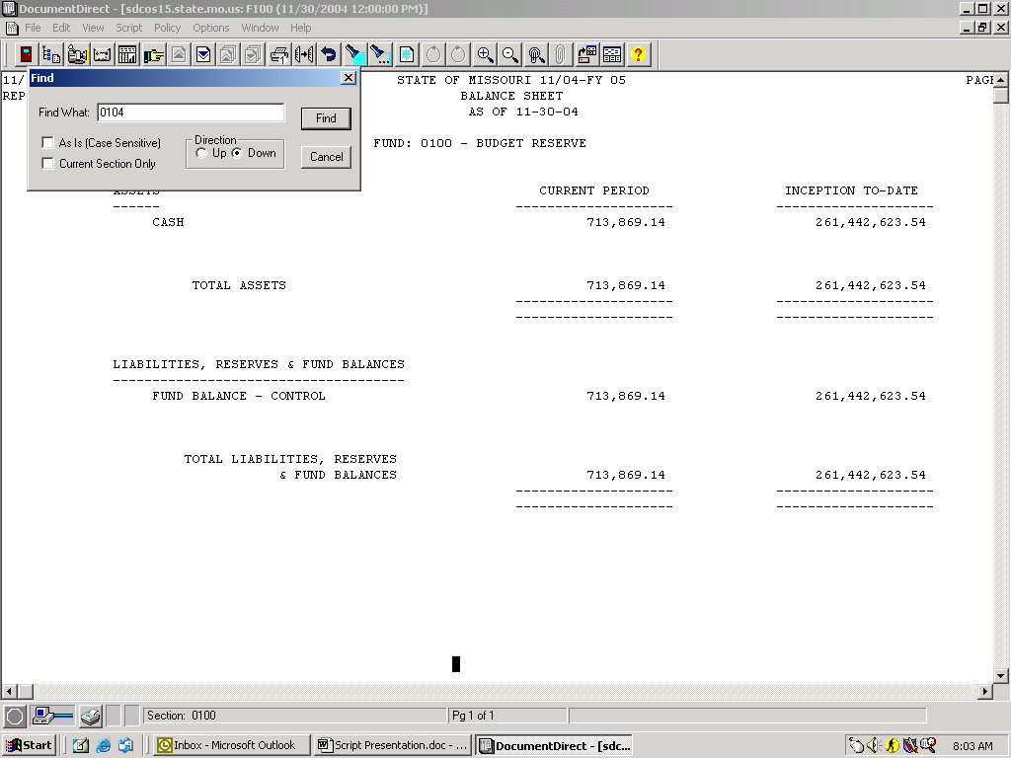

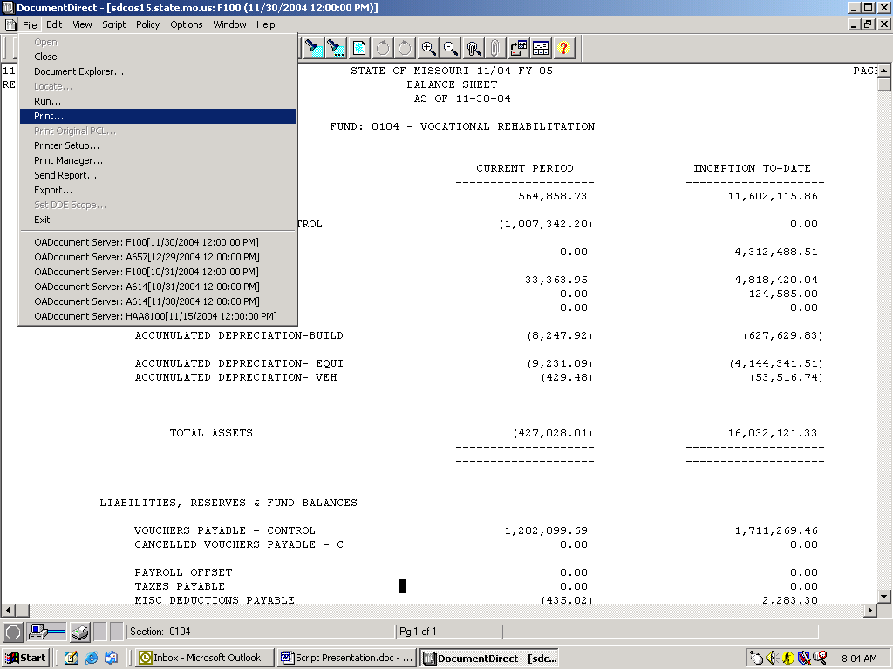

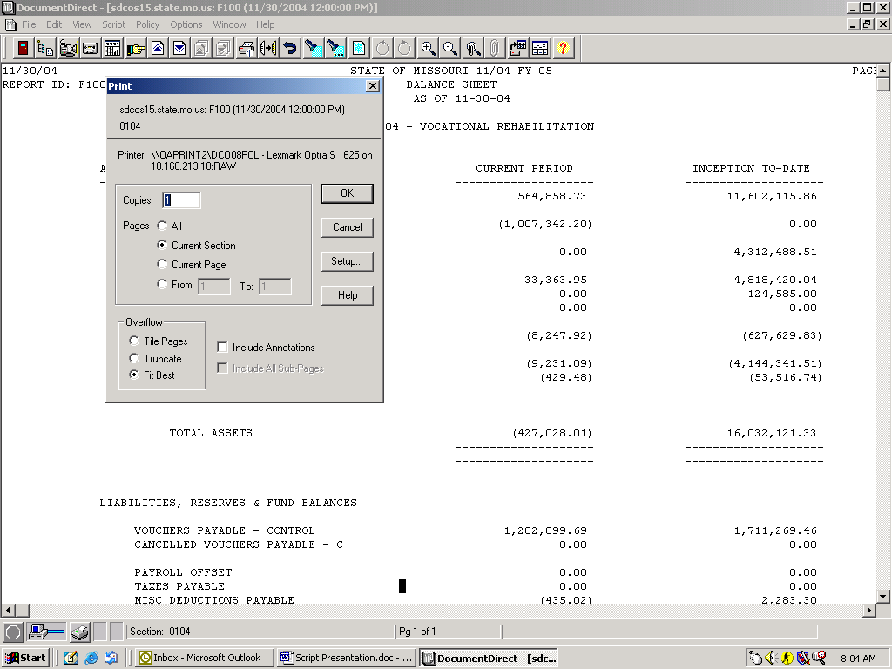

- After you are finished finding and printing your pages, select Script/Stop Recording or select the Script Recording icon to stop recording.
- To save the Script select Script/Save Script and save the Script.
- To use the Script next month to print our fund pages you would open up the report in Mobius set your print settings and then select Script/Playback and select your script. Automatically your script will find and print the pages that you recorded last month.

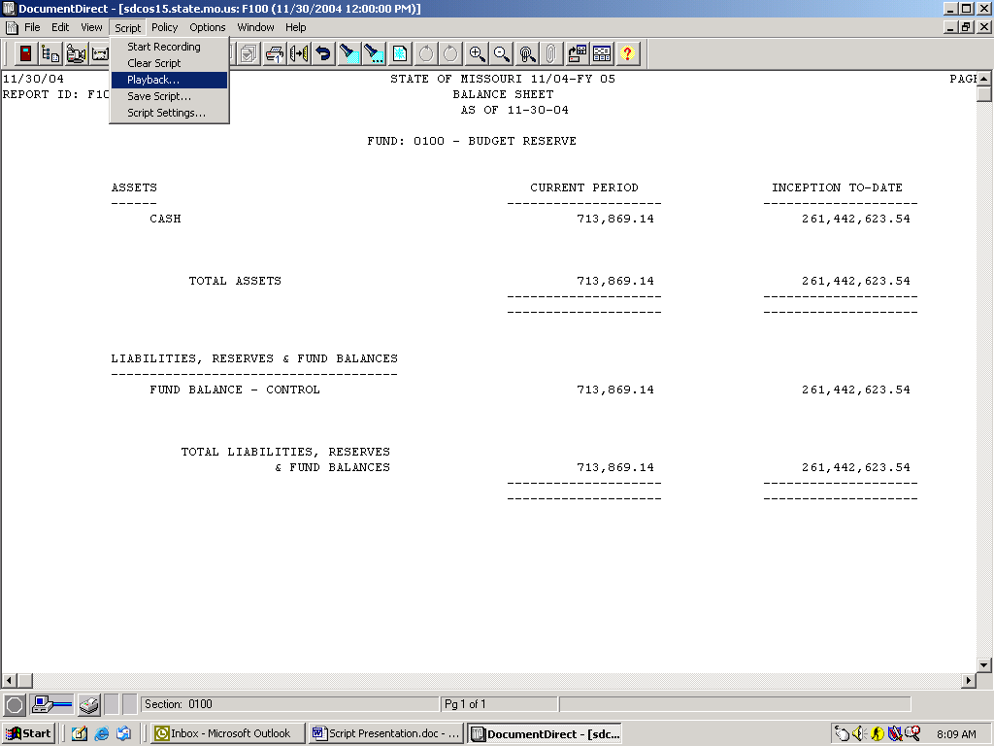

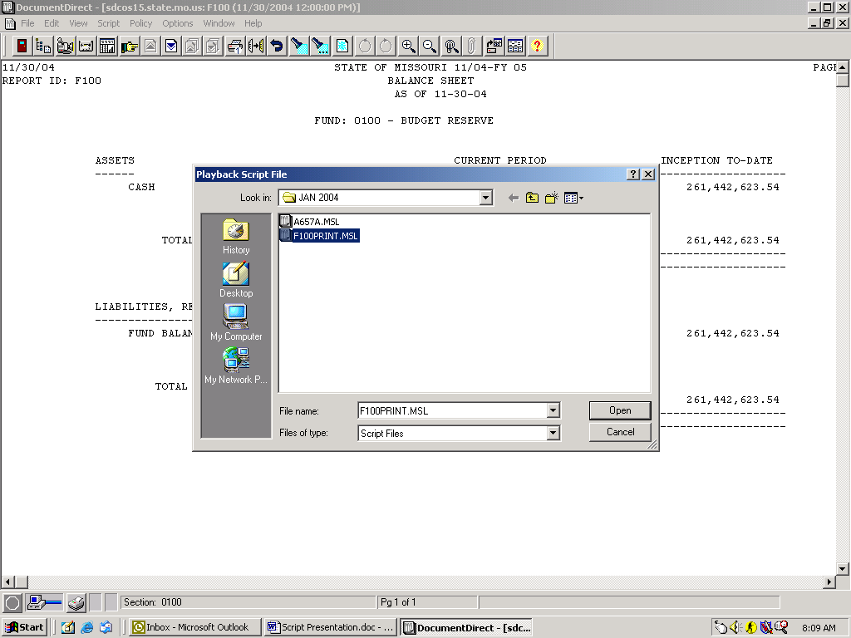

- To see the programming for the Script you can use Note Pad or Word Pad to view the actual programming language of the Script. You can also uses this to write your own script instead of using the recorder or use it to make modifications to a recorded script which is what we are going to do next.
- To see the programming for our existing script open up the script using Note Pad or Word Pad. Be sure to select All Files in the Files of Type box. Script files have a .MSL extension.
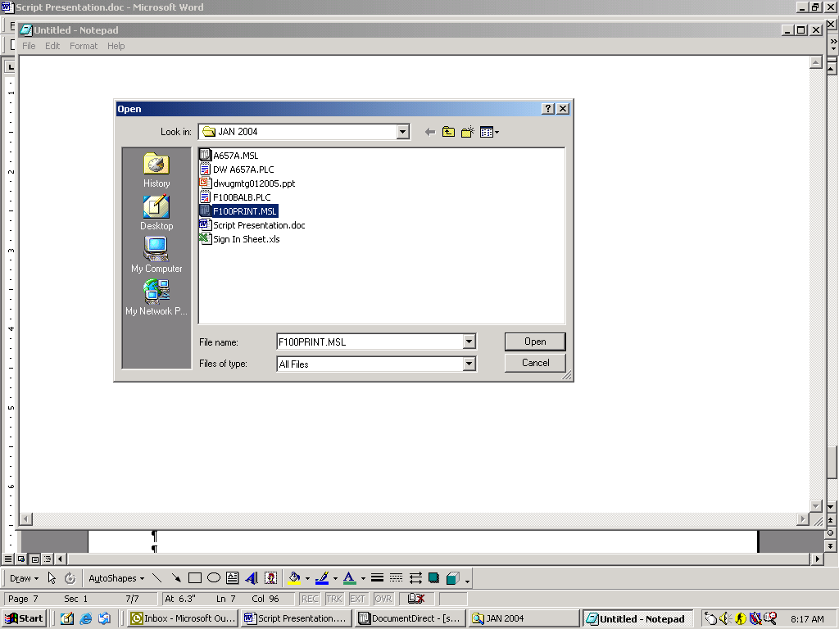

- Review the programming language to see if it has recorded the steps you expected it to.

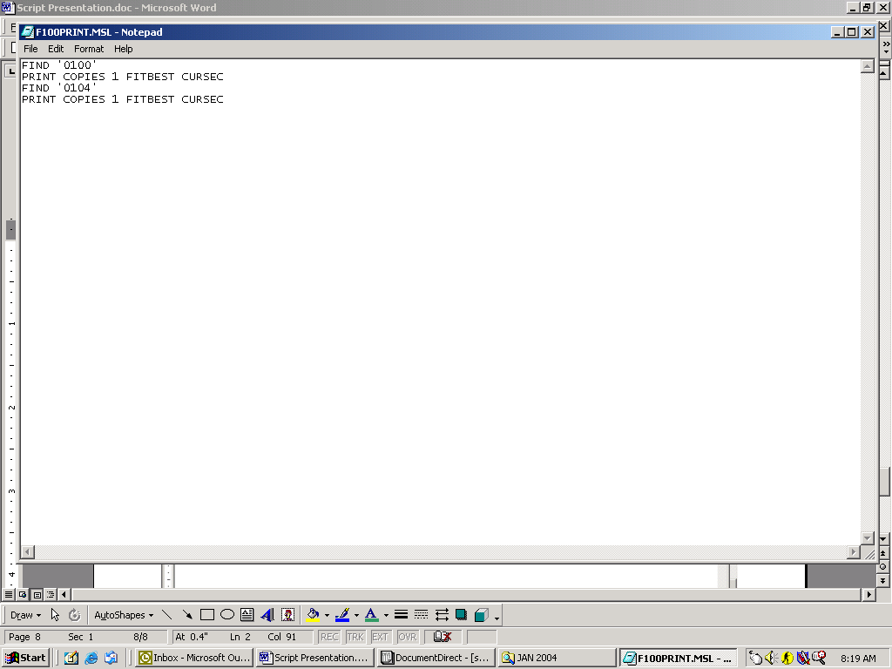

- The text looks ok. We now want to record one script that will run multiple policies for us.

Script to Run Policies

- Open up the Mobius report you are going to run your policies on.
- Select Scrip/Start Recording or the Start Recording Icon as noted above.

Select Policy/Load Policy and select the first policy to run.
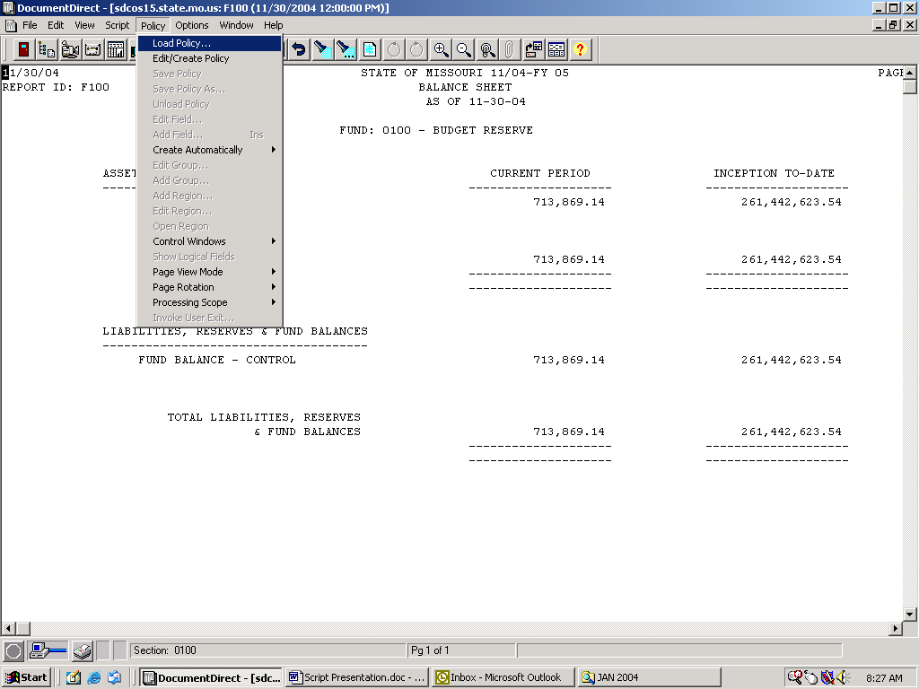

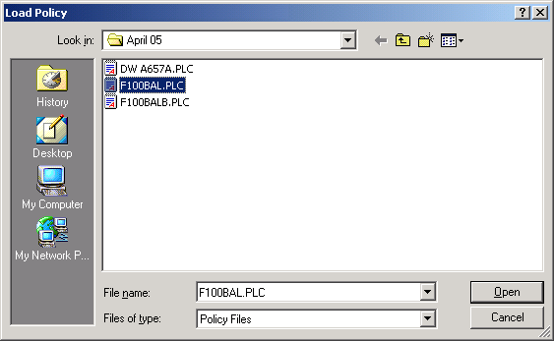

- Select File Export
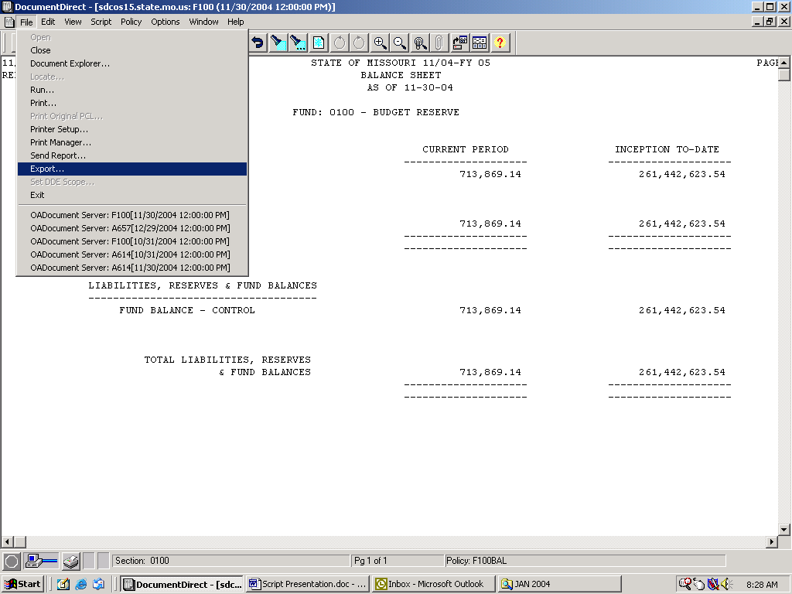
Complete the file name to export and perform the export as normal by selecting the Save button
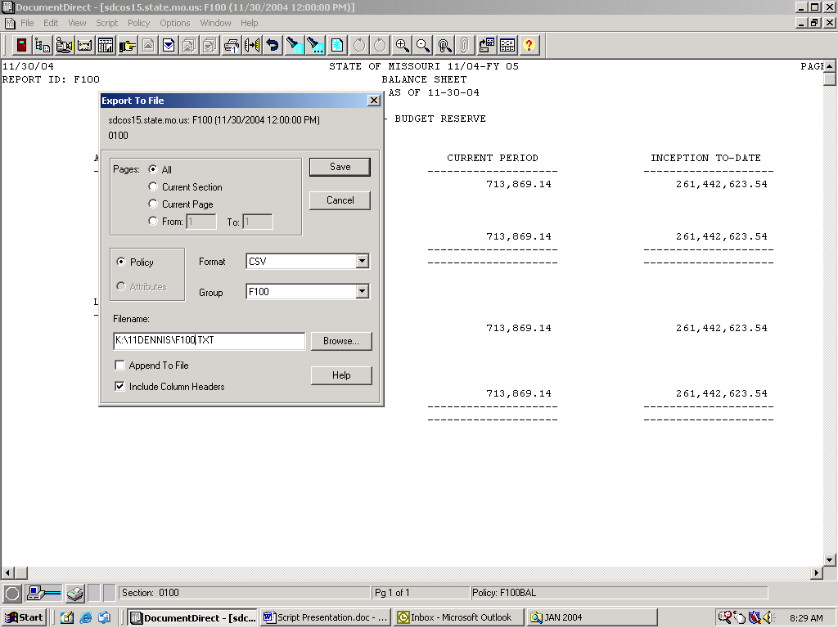
- Find the next Policy and open and run the next policy as noted above.
- Stop Recording by selecting Script/Stop Recording or the Stop Recording Icon.
- Save the Script by selecting Script/Save Script as noted above in the instructions for using a script for printing reports.
- The script we have recorded is set to run two policies in a row for one particular version of a report. If we need to change or remove the programming language we will need to use Word Pad or Note Pad to delete the verbiage that specifies which report version the script was recorded for.
- As we did before when we looked at the program for the Print Reports script use Word Pad or Note Pad to open up your script.
- The program verbiage for our script is shown below:

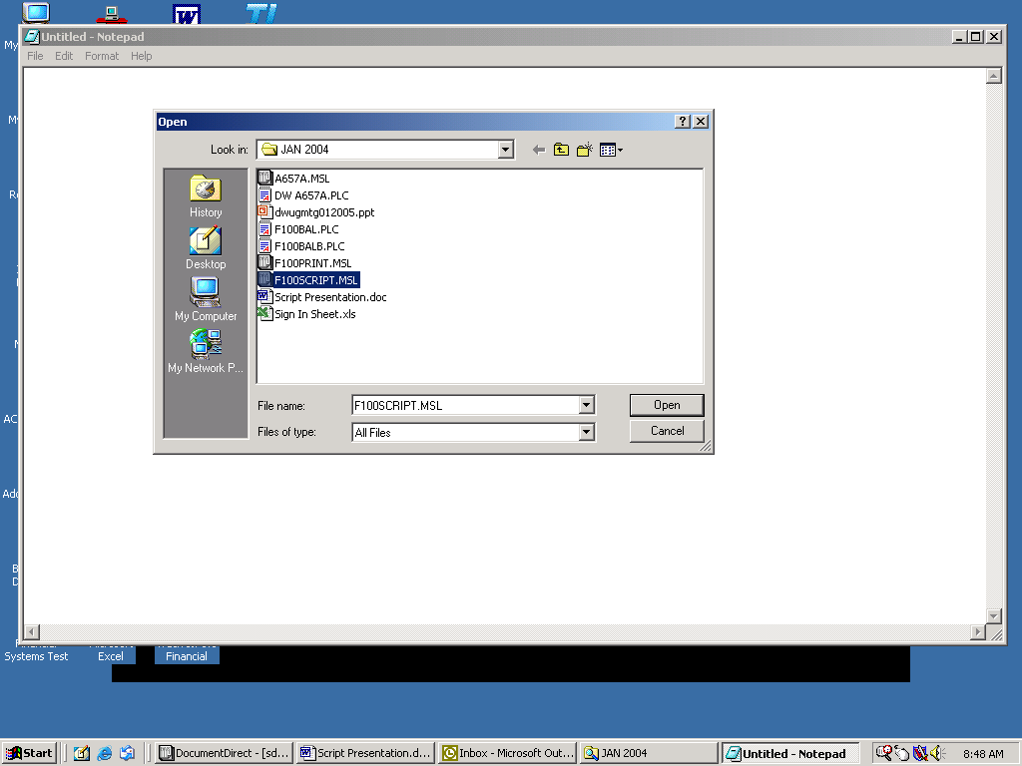
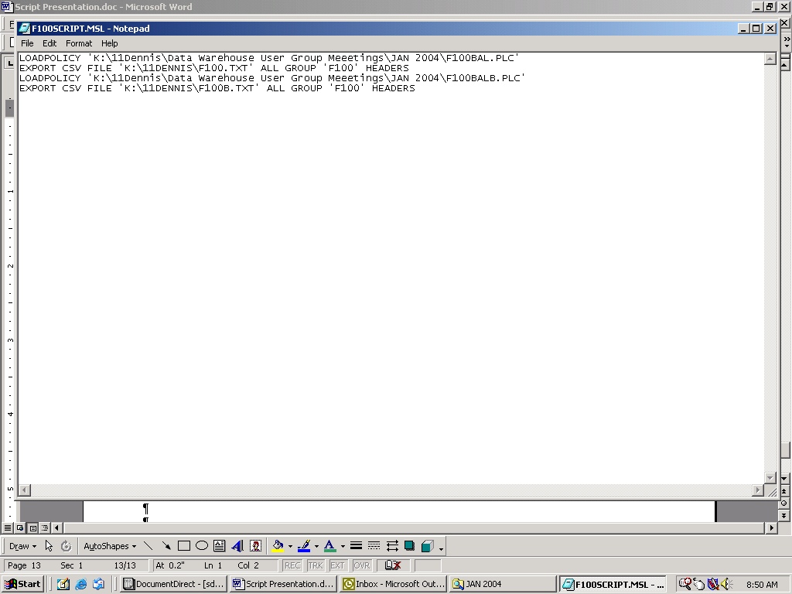
- In this particular case the verbiage does not need to be modified.

